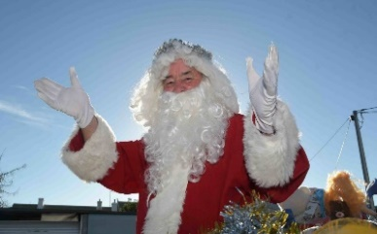
CHRISTMAS PARADE
Tailem Bend

Dear Stall Holder,
The 2021 Tailem Bend Christmas Parade will be held on Saturday the 11th of December. Please complete and return the application form and site fee of $50 (Business) or $25 (Community Group) per site, your COC and your completed Council Food Permit (by Monday the 15th of November) to confirm your site. Please be aware of a couple of Committee policies which may affect your entry:
- No alcohol
- Stall holders are required to be self-sufficient, please provide your own power, shade, tables, necessities, signage and advertising.
- Food Products must be listed and approved by the Committee.
- All food stall participants must complete a food permit form and submit to us by Monday 15th, November. Forms available on our website http://www.tailembendprogress.com.au/
- Stall holders are responsible for maintaining a clean safe area.
- Please provide a copy of a current Public Liability Insurance
- Stall holders not willing to comply with these rules can be refused entry.
- If you have any queries regarding the parade, please contact me on the details listed below.
- Confirmation will only be confirmed on receipt of payment of site fee.

Kind Regards

Maxine Kiddie
Parade Co-Ordinator TBCP Committee
(0439 387 750)
Bank SA Tailem Bend
Tailem Bend Christmas Parade
BSB: 105 – 060
Account #: 0359 03140
Please quote your stall name or Business as a reference

Sandy Przibilla
Parade Secretary TBCP Committee
(0419856744)

Email: tbchristmasparade@gmail.com
PO Box 278, Tailem Bend SA 2560

tbchristmasparade@gmail.com

CHRISTMAS PARADE
Tailem Bend

Stall Holder 2021 Tailem Bend Christmas Parade

NAME OF GROUP / CLUB OR INDIVIDUAL PERSON: _____________________________________

________________________
ARE YOU A BUISNESS: ◻ COMMUNITY GROUP: ◻
NAME OF STALL: _________________________________________________________________
FOOD ◻ Type: ________________________________________________________________
NOVELTY ◻ Product / Game: _____________________________________________________
MERCHANDISE ◻ Product: _______________________________________________________
OTHER ◻ ___________________________________________________________________
 
VAN ◻ MARQUEE ◻        OWN POWER ◻
DIMENSIONS OF SITE REQUIRED Width_________________ X Depth__________________

Contact Person: ___________________________Phone / Mobile: _____________________________

Postal address: __________________________________________________________________
Email: _________________________________________________________________________

Please attach: Completed form ◻ COC Public Liability Insurance ◻ Food Permit ◻ 

